LOVE MONTH NEWS FROM DOWNTOWN KINSTON REVITALIZATION 02/2022
Valentine’s Day We want to know what your business plans are for Valentine’s Day so we can help promote it. Like and follow the Pride of Kinston Face Book page and tag us on your business posts so we can share. (We still have to merge the Pride and DK pages for the name change.)
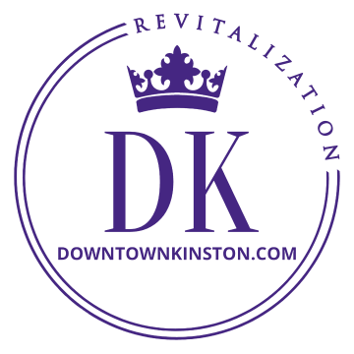
Downtown Businesses Are you aware that we have a closed group Face Book page exclusively for downtown merchants? It is to help facilitate communication between merchants and DK, specifically to help each other share your promotions and to help DK keep you more directly informed about downtown. It is not for complaining like other platforms, but rather intended to help each of you grow business as neighbors helping neighbors by sharing business info with each other. Please go to Pride of Kinston Downtown Merchants page and request to join.
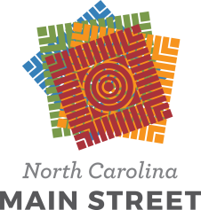
Street Pole Banners In 2021 we received a grant and matching funds from Electricites and our local Woodmen Lodge 46 for street pole banners in the MSD (Municipal Service District). We felt it was important to seize the opportunity to tell our story rather than purchase stock banners from a catalogue. Brandon Potter created beautiful graphics for a collection of custom banners that do just that.
North Carolina Main Street Since 1984 downtown Kinston has belonged to the National and North Carolina Main Street programs that help guide the revitalization of historic commercial districts. The 2022 Annual Conference, Healthy Communities Begin on Main Street, takes place March 8-11 in Statesville. Our State conference is one of the best. All are welcome to register for this virtual conference to learn more about revitalizing downtowns in North Carolina. Register at https://www.ncmainstreetandplanning.com/conference-home.
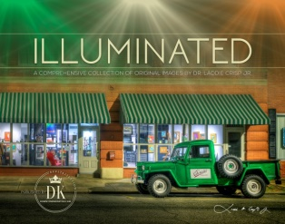
Kinston in Pictures Do you have a copy of Laddie Crisp’s magnificent photos of Kinston? They make great additions to your personal Kinston library collections as well as gifts. Get yours while they remain available from our office or website (www.downtownkinston.com), or Leon Thomas Treasures on W North St, downtown.

The DK Board meets the last Thursday of the month at 5:30 PM at the library. You are welcome to attend the meetings as a guest as well as join one of the committees to help with
the transformation of downtown.

Leon Steele, Director of Downtown Revitalization, lsteele17@suddenlinkmail.com, 252-522-8003
Follow Pride of Kinston/Downtown Kinston Revitalization on FB for lots of updates
And visit our website at www.downtownkinston.com

